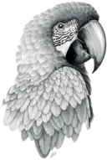

**OKTOBERFEST MENU**

**SHARING STARTERS…**

Black forest ham

Peppered salami

Blue Cambozola

Smoked Bavarian cheese

Rye sourdough

Pickles

**SHARING MAINS…**

Bratwurst, slow roast onions

Roast chicken thighs, mushroom sauce

New potato, gherkin, sour cream & herb salad

Tomato, beetroot & radish salad, pumpkin seeds

Sauerkraut

(Fries for kids)

**SOMETHING FOR LATER TO SOAK UP THE BEER…**

Glazed salted pretzel

Cheese sauce & curried mustard mayonnaise